Hello,

Thank you for booking your free 30 minute equine e-learning consultation call!

To help me prepare for the call, and so that we can make the most efficient use of your time, it would be beneficial for you to fill out this short questionnaire about your business and your goals.

Thank you, and I look forward to talking with you soon!
Sincerely,

Siobhan “Chevy” Allen
The Social Stockwoman
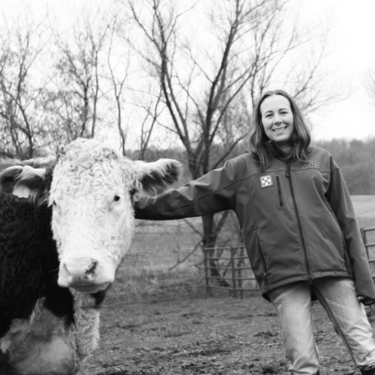

Name:
Farm/Ranch/Business Name:
Do you have a Facebook page for your business? If so, please list the link.
Do you have a website for your business? If so, please list the link.
What services do you offer, and at what prices?

Who is your ideal client? (Age, gender, where do they live, what do they do, income, family, interests/hobbies, lifestyle, etc.)

What challenges do you face instructing/coaching your clients?

Have you created any instructional materials already? (Such as articles, blog posts, videos, etc.)

Are there any questions that you want answered, or topics covered during our call?

Thank you! Please email this questionnaire to socialstockwoman@gmail.com

